VLSI Design

Electronics and Telecommunication, T.E. SEM VI

Experiment No : 5

Title : _______________________________
_______________________________
_______________________________
_______________________________

Date of Performance: ____________

Name of the Student:
I.D No.:

Department of Electronics & Telecommunication Engineering

Experiment No.: 5 Date:

AIM: Implementation of Full Adder circuit using Inverting Property

REQUIRMENT : software LT Spice

THEORY:
Static adder circuit: One way to implement the full adder circuit is to take the logic equations which is given below and translate them directly in complementary CMOS circuitry. Some logic manipulation can help to reduce the transistor count. For instance, it is advantageous to share some logic between the sum and carry generation sub circuits, as long as this does not slow down the carry generation, which is the most critical part as stated preciously. The following is an example of such a reorganized equation set:

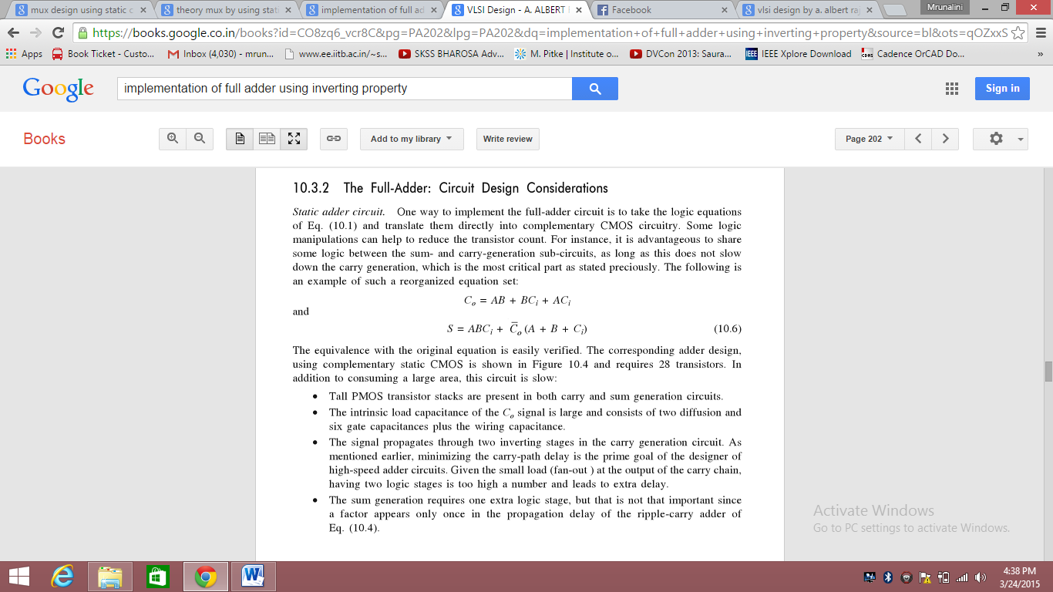
The equivalence with the original equation is easily verified .The adder design using complementary static CMOS based on inverting property requires 28 transistors.

Procedure :

Part A: For Full-Adder using Static CMOS Logic
- Draw the adder circuit using static CMOS logic based on above equation.
- Specify rise time , fall time, total time, T_{ON}, T_{OFF,} number of cycles.
- Observe the transient response of the circuit and verify the truth table of full adder.

Result and Discussion:

Conclusion:

